**Module-3(HTML-5)**

**Q1:** **What are the new tags added in HTML5?**

**Ans:** Html-5 introduced several new tags that provide better structure and improved functionality.

1. **<nav>:** Represent a section of navigation.
2. **<footer>:** Represent a footer section of a document section.
3. **<video> and <audio>:** Use to add audio and video content in html document file.
4. **<Section>:** Use to define a specific section in a web page.
5. **<mark>:** Use to mark or highlight the specified content with background color.
6. **<dialog>:** use to include dialog box in webpage.

**Example of html-5 tags:**

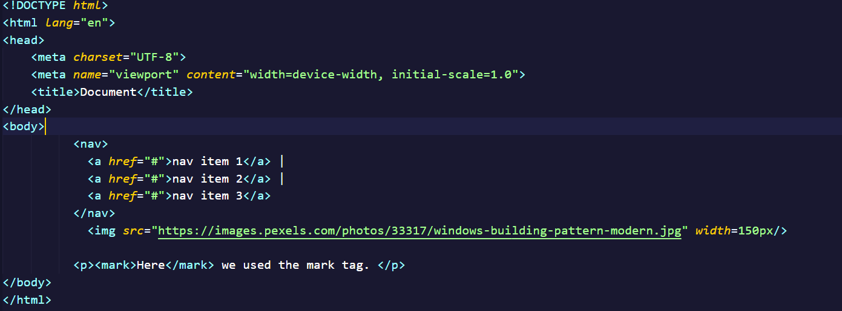

**Output:** 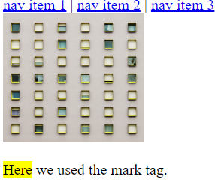

**Q2:** **How to embed audio and video in a webpage?**

**Ans: Audio:** Use the <audio> tag and specify the ‘src’ to embed video in web Page.

**Example:**

<audio src=”src” controls autoplay></audio>

**Video:** Use the <video> tag and specify the ‘src’ to embed video in web Page.

**Example:**

<video src=”src” controls autoplay></video>

**Q3:** **Semantic element in HTML5?**

**Ans:** Semantic elements in html-5 are tags that provide meaning and structure to the content of a web page.

Here some semantic elements given below:

**1.<header>:** Represent header content of a web page.

**2.<nav>:** Defines a section of navigation links.

**3.<main>:**  Represent the main content of the document.

**4.<section>:** Define stand alone section with related content.

**5.<time>:** Specifies a specific time

**6.<figure>:** Represents self-contained content, such as an image, screen shot etc.

**7.<figure caption>:** Provide a caption or description for given content in <figure>.

**Example:** 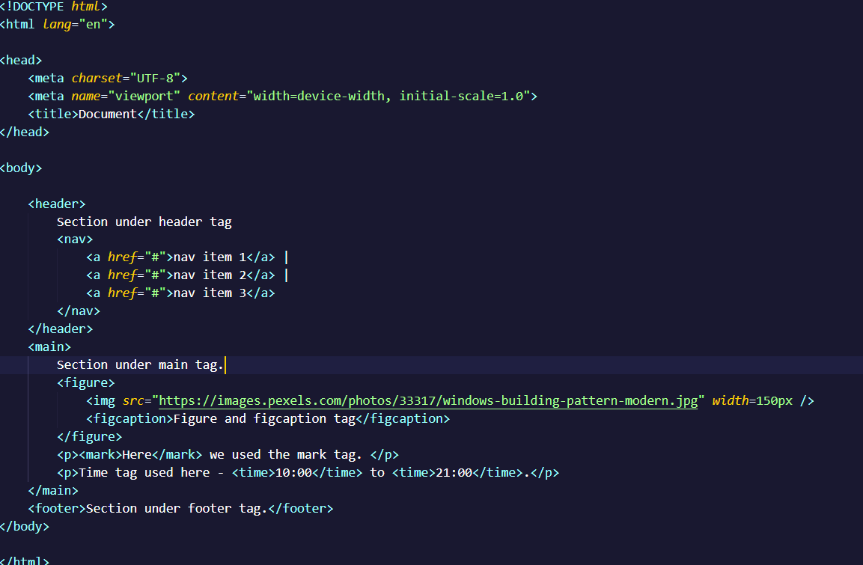

**Output:**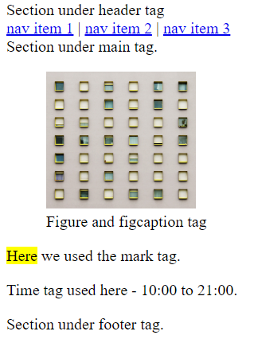

**Q4:** **Canvas and SVG tags**

**Ans: SVG:** SVG stands for scalable vector graphics. SVG image are resolution-independent and can be scaled without losing image quality.

The <svg> tag is an xml-based vector graphics format that allows for creation scalable 2D vector graphics. It uses XML syntax to define paths, and other graphical elements.

**Example:**

<svg width="500" height="300">

<rect x="0" y="0" width="200" height="200" fill="red"></rect>

</svg>

**Canvas:** The canvas tag is used to draw graphics, on the fly via java script. The canvas tag is transparent, and is only for container graphics, you must use a script to actually draw the graphics.

**Example:**

<canvas> This is a canvas tag </canvas>